Laboratory Safety Fundamentals
UC Learning Center Registration Instructions
The UC Laboratory Safety Fundamentals eCourse is REQUIRED for all research personnel before beginning work in the laboratory. In addition, UC policy requires lab safety refresher training every three years. Follow the instructions below for initial and recurring certification:

Initial Certification
Recertification
FAQs

After reading through these instructions, if you have questions or if you run into any difficulty, please feel free to reach out for help by emailing: learningcenter@ucsc.edu.

Happy Learning,
Your UC Learning Center Support Team

Initial Certification
Before working in a lab, you must complete the UC Laboratory Safety Fundamentals eCourse.

This process requires a desktop or laptop computer. Mobile devices are not supported.  - Go to learningcenter.ucsc.edu in order to login to the UC Learning Center.  - Click the orange Login button.  - Employee accounts are automatically created within 5-7 business days of your start date.  - For instructions on how to request a student account, click the “request form” link in the lower-left corner of the webpage.  - Enter your CruzID Gold username and password, as directed.  - Click the “Login” button.  - In the Activity Search field, type in “laboratory safety for research” and click the magnifying glass.  - If you cannot see the Activity Search field, try maximizing your browser window. The field will be hidden if the browser window isn’t large enough.  - Click the blue “Register” button.  - Click on the white space within the box of the UC Laboratory Safety Fundamentals.  - After you click the white space within the box, a green outline will appear:  - 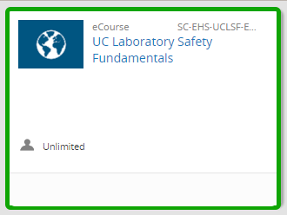  - Click the blue “Next” button.  - Click the blue “Submit” button.  - On the resulting screen, by the name of the course, you will see a green flag that says you are “Registered”.  - Click the green “Start” button to begin the activity.  This is the end of the Initial Certification instructions. | 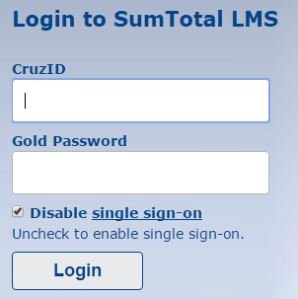  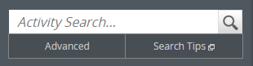  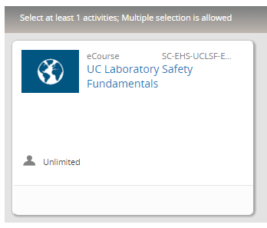

Recertification
If you have already completed the UC Laboratory Safety Fundamentals eCourse, you are eligible to take the Laboratory Safety Refresher eCourse - or, if there is a class available, you may take an Instructor-Led Training.

This process requires a desktop or laptop computer. Mobile devices are not supported.  - Go to learningcenter.ucsc.edu in order to login to the UC Learning Center.  - Click the orange Login button.  - Employee accounts are automatically created with 5-7 business days of your start date.  - For instructions on how to request a student account, click the “request form” link in the lower-left corner of the webpage.  - Enter your CruzID Gold username and password.  - Click the “Login” button.  - In the Activity Search field, type in “laboratory safety for research” and click the magnifying glass.  - If you cannot see the Activity Search field, try maximizing your browser window. The field will be hidden if the browser window isn’t large enough.  - Click the blue “Register” button.  Decide whether you would like to recertify via:  - UC Laboratory Safety Fundamentals eCourse (≈2.5 hours)  - Laboratory Safety Refresher eCourse (≈30 minutes)  - Lab Safety - Refresher Instructor-Led Training (ILT) Course. If there is no ILT Course currently scheduled, the selection will be greyed-out and will say “Registration blocked”.  - Click on the white space within the box of the activity you want to select:  - After you click the white space within the box, a green outline will appear:  - 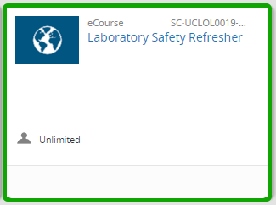  - Click the blue “Next” button.  - Click the blue “Submit” button.  - On the resulting screen, by the name of the course, you will see a green flag that says your are “Registered”.  - Click the green “Start” button to begin the activity.  This is the end of the Recertification instructions. | 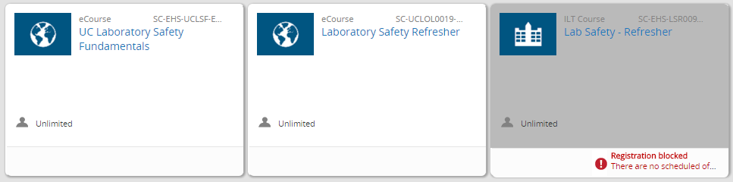  (Image offered for visual reference only,  not for legibility.)  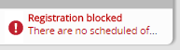  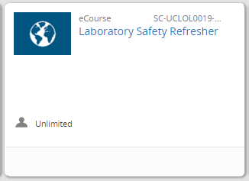  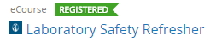

FAQs
If you have any questions that are not answered below, or if you need help for any reason at all, please feel free to reach out for help by emailing: learningcenter@ucsc.edu.

- Why does the phrase “Select at least 1 activities; Multiple selection is allowed”, even though there is only one activity to select?
  - This is a statement reflecting the fact that there will be multiple activities that can satisfy this requirement, in the future - after you have completed the required UC Laboratory Safety Fundamentals eCourse for the first time. You may ignore that statement and continue on with the process.
  - For grammarians: No, we don’t have access to change “activities” in the boilerplate verbiage. :^)
- When recertifying, and after I click Register, why does it say my “Required selection is complete; optionally you can select more activities”, when I haven’t even selected an activity yet?
  - This is a statement reflecting the fact that you have previously completed the UC Laboratory Safety Fundamentals eCourse, which is part of this list. The logic of the Activity Structure requires you to complete one of the selections listed, which you would have done, if you’re recertifying. However, the Certification requires that you revisit this Topic every three years to complete an selected activity again.
- Why does the phrase “Registration already processed” show up on the activity I want to select?
  - This appears when you have previously registered for this this activity, but haven’t yet completed it. You may ignore that statement and continue on with the process.
- Why is the ILT Course Lab Safety - Refresher showing up in my list of activities, after I’ve registered for the Laboratory Safety Refresher eCourse?
  - 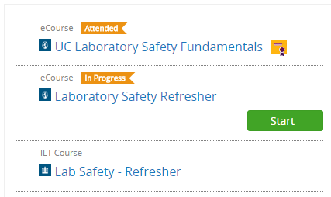
  - If there is no “Registered” flag , then you can ignore this listing.

